# Bitwise Operators Assignment

**Mandatory**

Q1. WAP to read a 8 bit unsigned integer, interchange the adjacent bits i.e D0  with D1, D2 with D3….. D6 with D7.  Display the final number.

Input: 0xAA

Output: 0x55

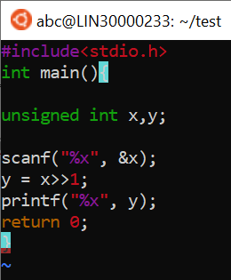

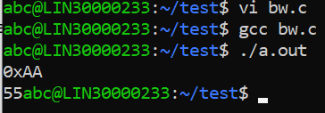

Q2. Count the number of 1s in the given byte and display:

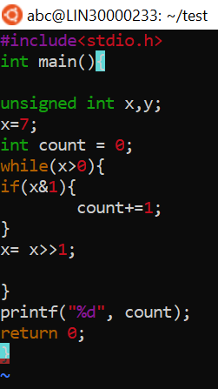

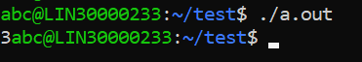

Q3. Generate odd and even parity bits for a given number. (consider a 32 bit number)

[Hint: You may reuse the solution created in Q2 and extend it further]

Q4. WAP to reverse the bytes in a 32 but unsigned integer using shift operator.

Input: 0x12345678

Output: 0x78563412

**Optional**

Q1. Write a menu driven bitwise calculator program. The user shall enter a 32 bit unsigned number to begin with.

* The calculator shall support operations
* setting a specific bit to 1
* clearing a specific bit to 0
* asking value of a specific bit
* extracting a submask by inputting the bit-offset and submask-width

Q2. Write a program to find out whether a given number is a power of 2 or not.